For 2015 samples (Enas)

Folder (git) :
Mouse_Eimeria_Databasing/raw_data/Eimeria_detection/Eimeria_oocysts_2015_Enas.csv

Method :
cf protocol 1 appendix + written and said that only 1 out of 8 squares were counted.

Problems :
Raw numbers (fecal weight and raw counts) were not found by Alice on Enas lab books on 4/01/2018. Given to Jenny (and recalculated by her) for her thesis. Hard to track back protocol (splitted in different documents).

Solution :
- consider the number given as “raw_oocyst_in_10_microL_div_by_8_squares”
- a total volume of 0.2mL
N x 8(squares) / 10(microL) x 1000(convert to mL) x 0.2(oocysts in feces) /fecal_weight_g (OPG)

For 2016 samples part 1 (Enas)

Folder (git) :
Mouse_Eimeria_Databasing/raw_data/Eimeria_detection/Eimeria_oocysts_2016_part1_Enas.csv

Method :
cf protocol 1 appendix + written and said that only 1 out of 8 squares were counted.
Raw numbers were cross-checked by Alice on Enas lab book on 4/01/2018

Problem :
incoherent feces weight in lab book (up to 4g, we never collect 4g of feces in a wild mouse). Hard to track back protocol (splitted in different documents).

Solution :
- consider the number given as “raw_oocyst_in_10_microL_div_by_8_squares”
- a total volume of 0.2mL
- a fecal weight of 0.4g (mean for year 2017 of what has been precisely collected)
N x 8(squares) / 10(microL) x 1000(convert to mL) x 0.2(oocysts in feces) /0.4 (OPG)

For 2016 samples part 2 (Phuong)

to ask : how were weighted the samples? Get back the lab book.

Folder (git) :
Mouse_Eimeria_Databasing/raw_data/Eimeria_detection/Eimeria_oocysts_2016_part2_Phuong.csv

Method :
cf protocol 1 appendix + neubauer chamber. Total volume : 4mL.
Raw numbers were not cross-checked by Alice on Phuong lab book on 4/01/2018

Problem :
incoherent feces weight (up to 6g, we never collect 4g of feces in a wild mouse).
Hard to track back protocol (splitted in different documents).
Lab book not found.
Total volume : 4mL is questionnable.
Seems underestimated.

Solution :

- a fecal weight of 0.4g (mean for year 2017 of what has been precisely collected)
N x 10000(neubauer squares, convert to mL) x 4 (oocysts in feces) / 0.4 (OPG)

For 2017 samples (Lorenzo)

Folder (git) :
Mouse_Eimeria_Databasing/raw_data/Eimeria_detection/Eimeria_oocysts_2017_Lorenzo.csv

Method :
cf protocol 2 appendix

Results

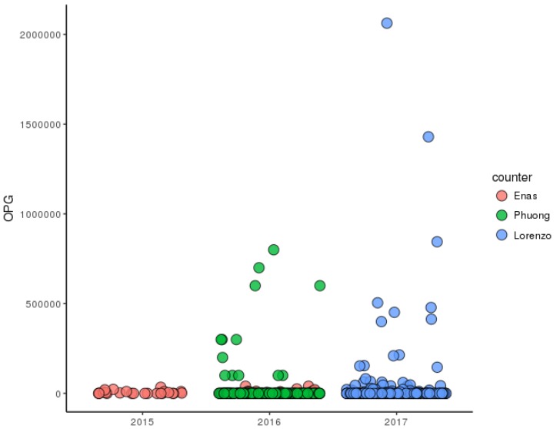
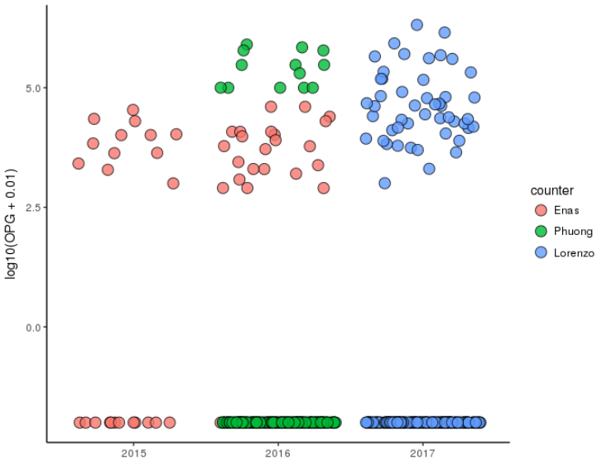

Enas2015: N = 24 (12 pos; prev = 50%) WARNING
Enas2016: N = 106 (22 pos; prev = 21%) WARNING
Phuong2016: N = 109 (13 pos; prev 12%)
Lorenzo2017: N = 235 (31 pos; prev 13%)

Idea :
- take only the non null data, log10 (normally distributed)
- center with 2017 as reference
- go back to counts (10^)
Example:
# Group 1 : Enas, 2015
eimeria_summary_df$OPG_scaled[eimeria_summary_df$counter == "Enas" &
eimeria_summary_df$year == 2015 &
eimeria_summary_df$OPG != 0] <-
10^(scale(log10(eimeria_summary_df$OPG[eimeria_summary_df$counter == "Enas" &
eimeria_summary_df$year == 2015 &
eimeria_summary_df$OPG != 0]),
center = TRUE, scale = FALSE) +
mean(log10(mycenter)))
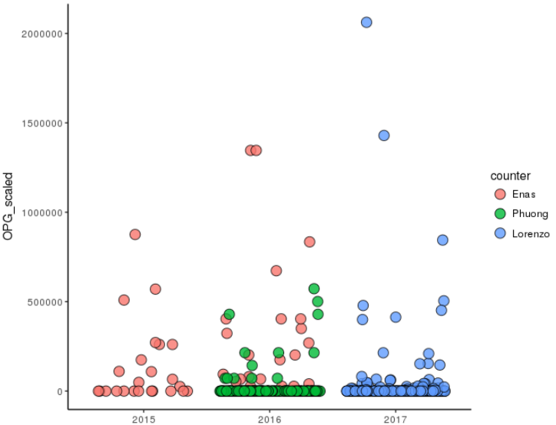
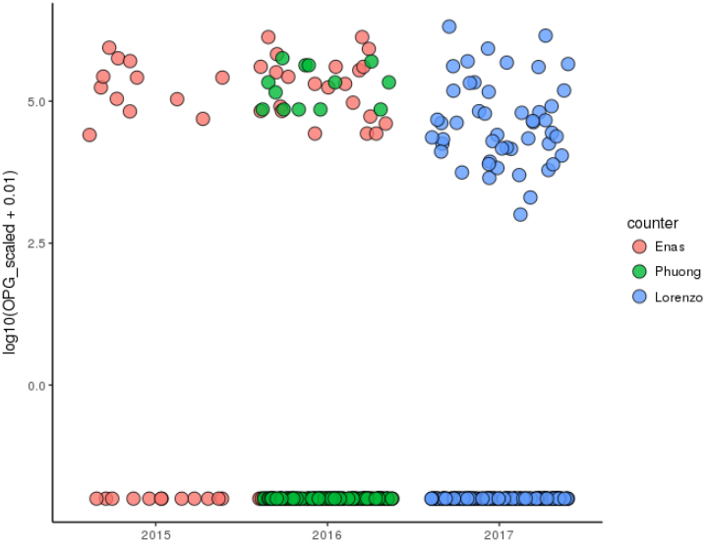
Appendix

Protocol 1. Mail Enas 6/12/2017

Extracting Eimeria oocysts from mouse faeces
- Shake tubes containing faeces in 2% Potassium dichromate (falcons or) until pellets are broken (if it was in Eppendorf transfer to falcon)
- Spin at 4200rpm (centrifuge can’t spin faster when using falcon tubes) for 10min.
- Pour out supernatant and re-fill with water
- Break up pellet using some stick (wooden skewer or something) and shake well
- Repeat washing steps 2 and 3 but re-fill with saturated salt solution
- Make sure to a) not overfill with salt solution (have to be able to add at least the same amount of water to it later) and b) to mix the pellet with the salt solution really well
- Repeat 2
- Collect supernatant (salt) in a fresh tube and fill up with water (at least 50:50), this will dilute the salt and enable the oocysts to pellet
- Repeat 2
- Pour out supernatant and dissolve pellet in a bit of water
- Check for oocysts under the microscope
- If oocysts present, fill up tube with water and wash one more time:
- Pour out supernatant and dissolve the pellet in a 2 ml of 2% Potassium dichromate and count concentration
- Leave to stand at room temperature until sporulated (don’t put in fridge before sporulation has occurred!!)
- For counting (direct slide counting for both 2015&2016) as follow; shake oocyst solution well and dispense 10ul over clean glass slide; perform a total oocyst count on the slide following a zigzag direction from top to bottom, left to write.
- Convert row count to Oocyst per gram count (opg)* ( for 2016 samples only).
*the opg equation is in the data file, see saefile.

Protocol 2.Protocol_25 October 2017_ Alice Balard

Flotation : 14ml falcons with feces (<3mL of feces) and Potassium dichromate (2.5%)

- fill up to 10mL with distilled water
- shake tubes + use stick until pellet dissolves/breaks
- centrifuge at 4200rpm, 20°C, 5 min → discard supernatant
- repeat 2 more times
- fill 14ml falcon until 8 ml mark with saturated salt solution, break pellet again
- centrifuge at 4200rpm, 20°C, 10 min → collect supernatant in 50 ml falcons
- repeat (fill 14ml falcon with salt solution until 8 ml mark, break pellet, centrifuge 5 min), collect supernatant in same 50 ml falcon as before, throw away 14ml falcons

- fill 50ml falcons with distilled water until 50ml mark
- centrifuge at 4200rpm, 20°C, 10 min → discard supernatant (carefully, with pasteur pipette)
- keep just the pellet and a small layer of salt solution (Oocysts)
- dissolve pellet in 1ml PBS
- for long term storage add 1mL 2.5% potassium dichromate

- for counting with a Neubauer chamber : use 20µl (10µl on each side) to count the oocysts

Extra steps:
Washing :
add distilled water in 50mL tube with oocysts, centrifuge 10min at 1800g RT, keep pellet
Sporulation oocysts :
>9 days in potassium dichromate, 30°C water bath

